Assignment 1

Q1:

1. 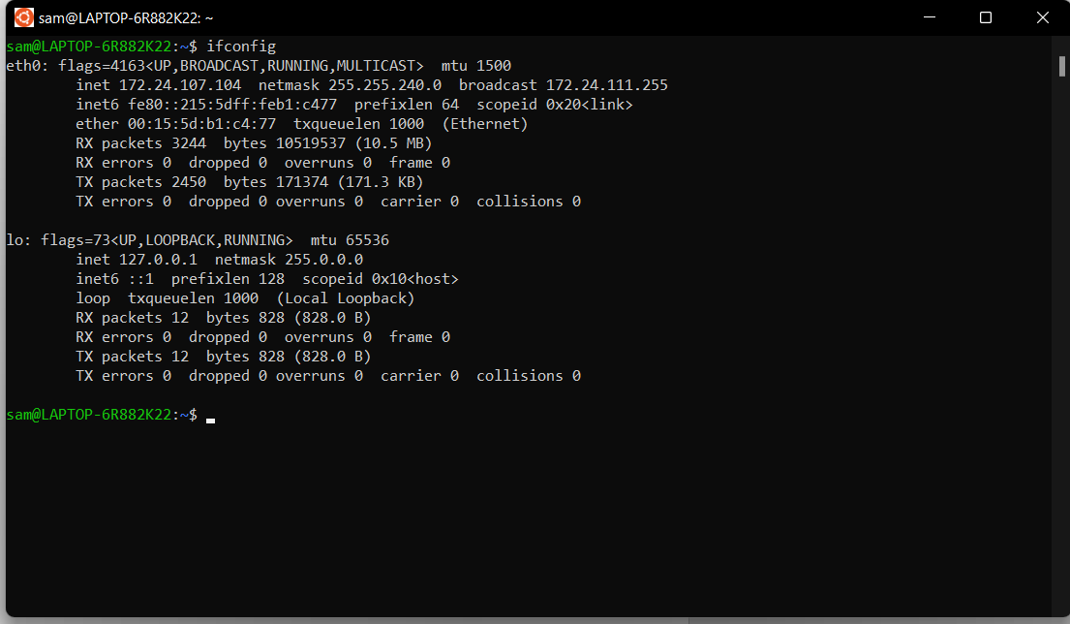

Ip address: 172.24.107.104

b.

Yes, they are different reason being is 122 ip address is uses for large networks and has 8 bits for network and 24 bits for hosts. But, 172 and 192 address is for private use.

Q2.

1. 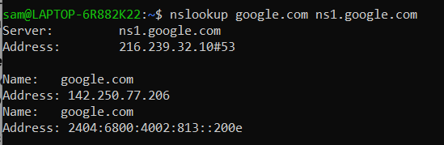

Here addresses of the authoritative server for the specified domain.

Server’s Ip4: 142.250.77.206

Server’s ip6: 2405:6800:4002:813::200e

How I do it?

At first doing nslookup google.com doesn’t give authoritative answer.

So, to get that we run the following command:

nslookup -type=soa google.com

Here, soa = start of authority with information about a zone.

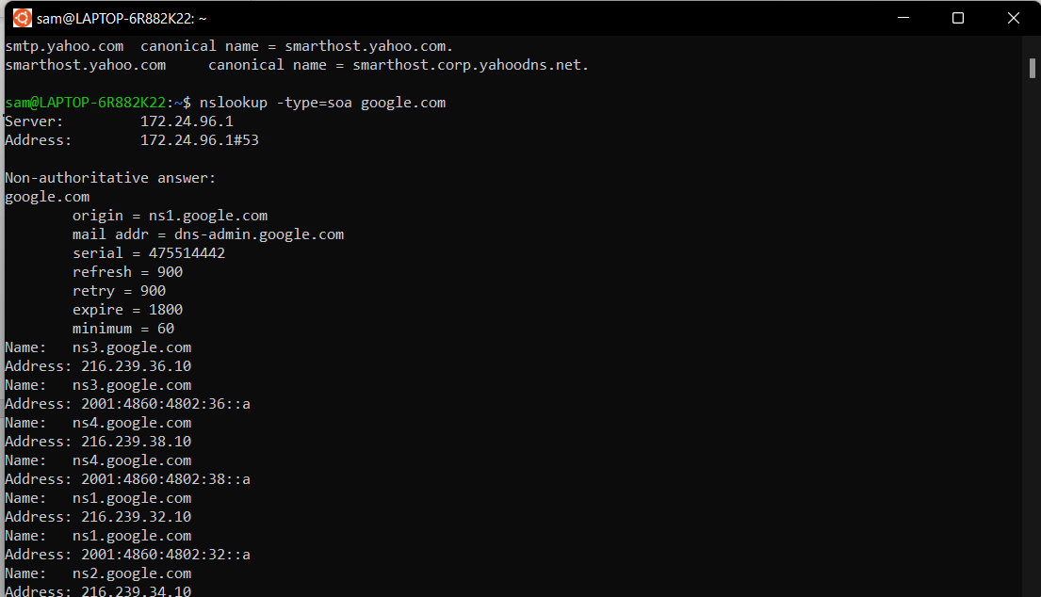

Here, in the origin we see the primary server name for the google and above result is still non-authoritative which means we receive response from a cache of a DNS server.

Now, be getting this we’ll finally able to get authoritative answer we specify name server as *ns1.google.com*:

By following commands:

nslookup google.com ns1.google.com

1. 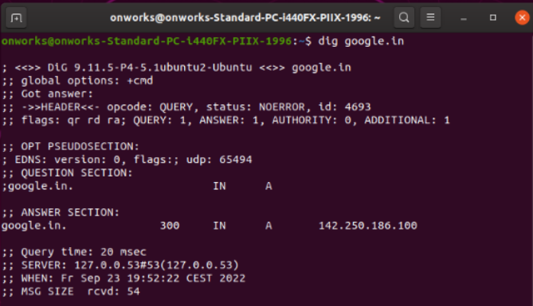

Here, time to live (TTL) is 300 sec

Q3.

1. 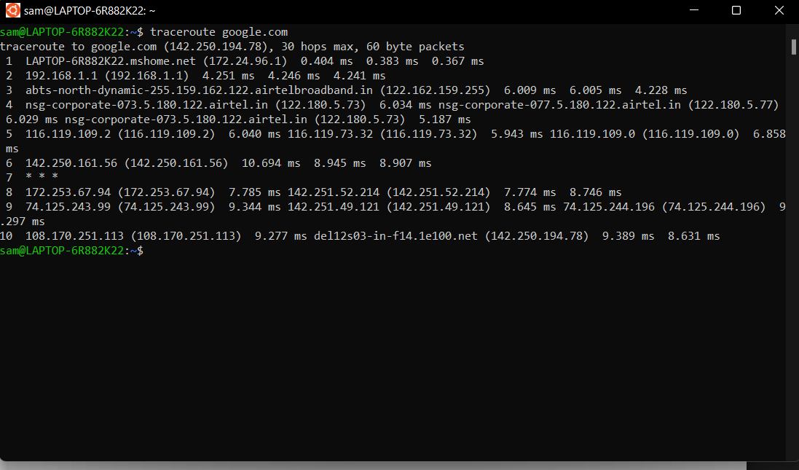

There, are 10 intermediate host we see.

After, every ip addresses we see 3 millisecond time. Which, are or a packet to get to the hop and back to your computer that is also referred as latency.

Traceroute sends three packets to each hop and displays each elapsed time to measure how consistent or inconsistent the latency is at that time

Ip addresses and average latency:

|  |  |
| --- | --- |
| Ip Addresses | Average Latency |
| 172.24.96.1 | 0.384 |
| 192.168.1.1 | 4.246 |
| 122.162.159.255 | 5.414 |
| 122.180.5.73 | 5.75 |
| 116.119.109.2 | 6.280 |
| 142.250.161.56 | 9.515 |
| 172.253.67.94 | 8.101 |
| 74.125.243.99 | 9.095 |
| 108.170.251.113 | 9.099 |
|  |  |

1. Using command

ping -c 100 google.com

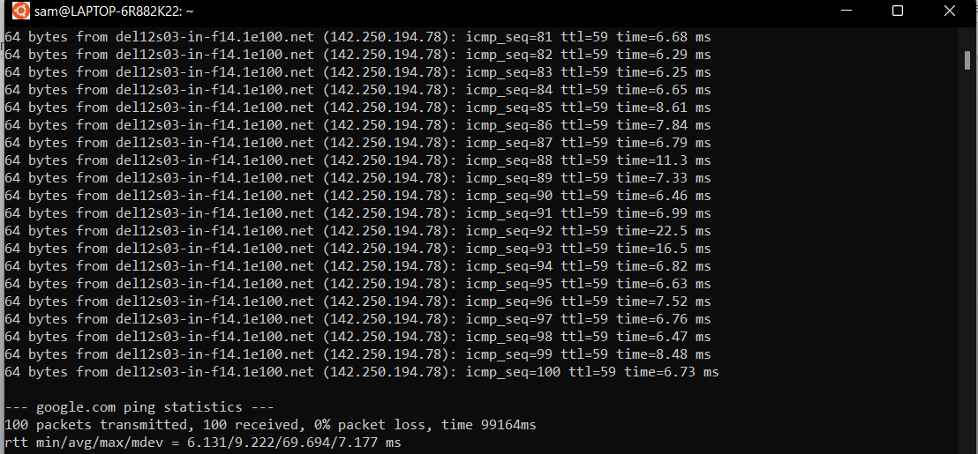

Average is 9.222

1. Using

ping -c 100 columbia.edu

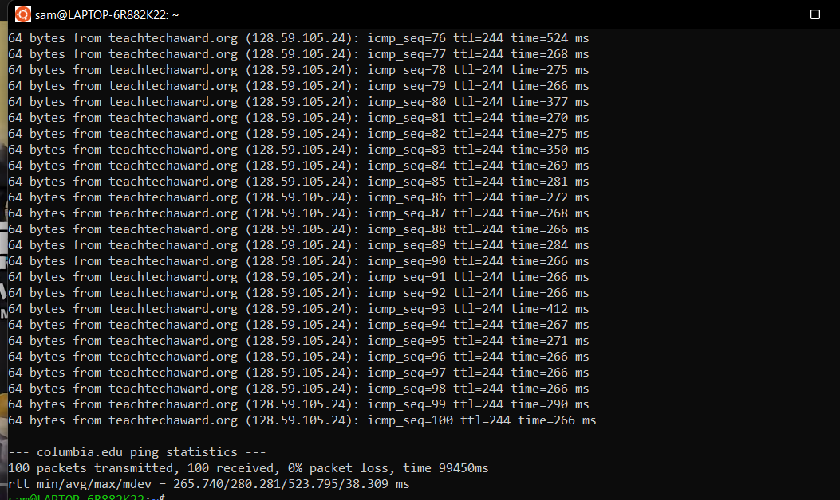

Average Latency: 280.281 ms

1. No, reason being it wait for acknowledgement that’s why ping latency is different.
2. No, reason being it wait for acknowledgement that’s why ping latency is different.

f. Both hops of google and columbia are same i.e 30 hops max.

Reason for same:

Diameter of internet is 30 or 64 hops.

If it doesn’t reach destination by 30 means then it will show host is unreachable.

Q4. 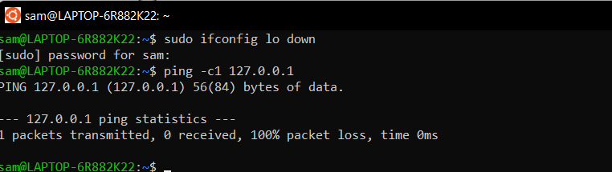

First command:

sudo ifconfig lo down

This command will temporarily disable the loopback interface. (Here, lo means loop interfaces.)

ping -c1 127.0.0.1

This command will check connectivity of the loopback interface by sending packets to it and receiving the same.

Now, for how we failed

We can make this ping command fail for 127.0.0.1 by temporarily disabling the loopback because 127.0.0.1 is the address of loopback interface. If, using ifconfig and try pinging, it will show output given above.

PS: we can enable back using sudo ifconfig lo up

Q5.

For HTTP request packets:

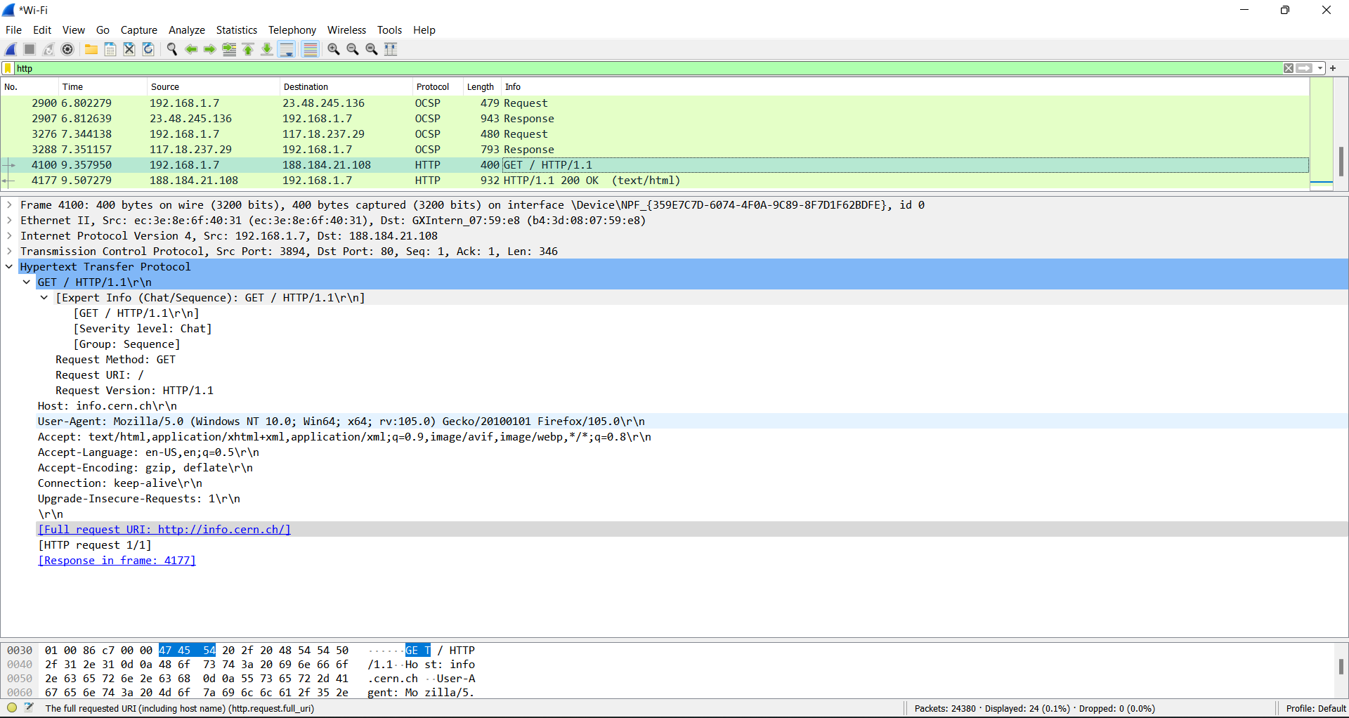

1. HTTP request type

Answer: GET type

1. User agent type

Answer:

User-Agent: Mozilla/5.0 (Windows NT 10.0; Win64; x64; rv:105.0) Gecko/20100101 Firefox/105.0\r\n

1. HTTP request packet’s URL

Answer:

Full request URI: <http://info.cern.ch/>

For HTTP response packets:

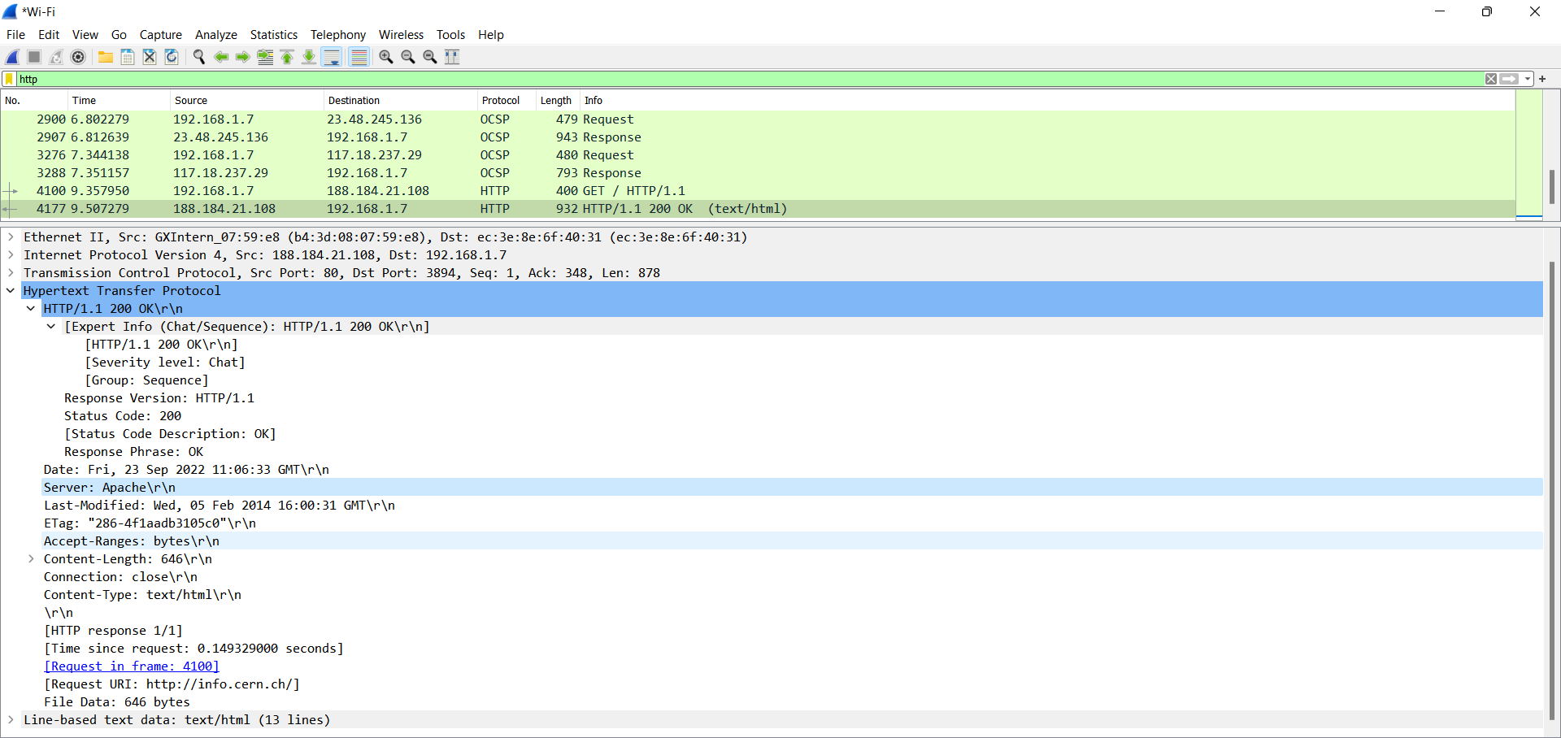

1. HTTP response code

Answer: 200

1. HTTP response description

Answer: OK

1. Name and version of the web server

Answer:

Name: Apache

Version: 1.1

*How many web objects get downloaded? Were they over the same TCP connection or different connections?*

4 web objects downloaded and they are downloaded with 2 same and 2 different.

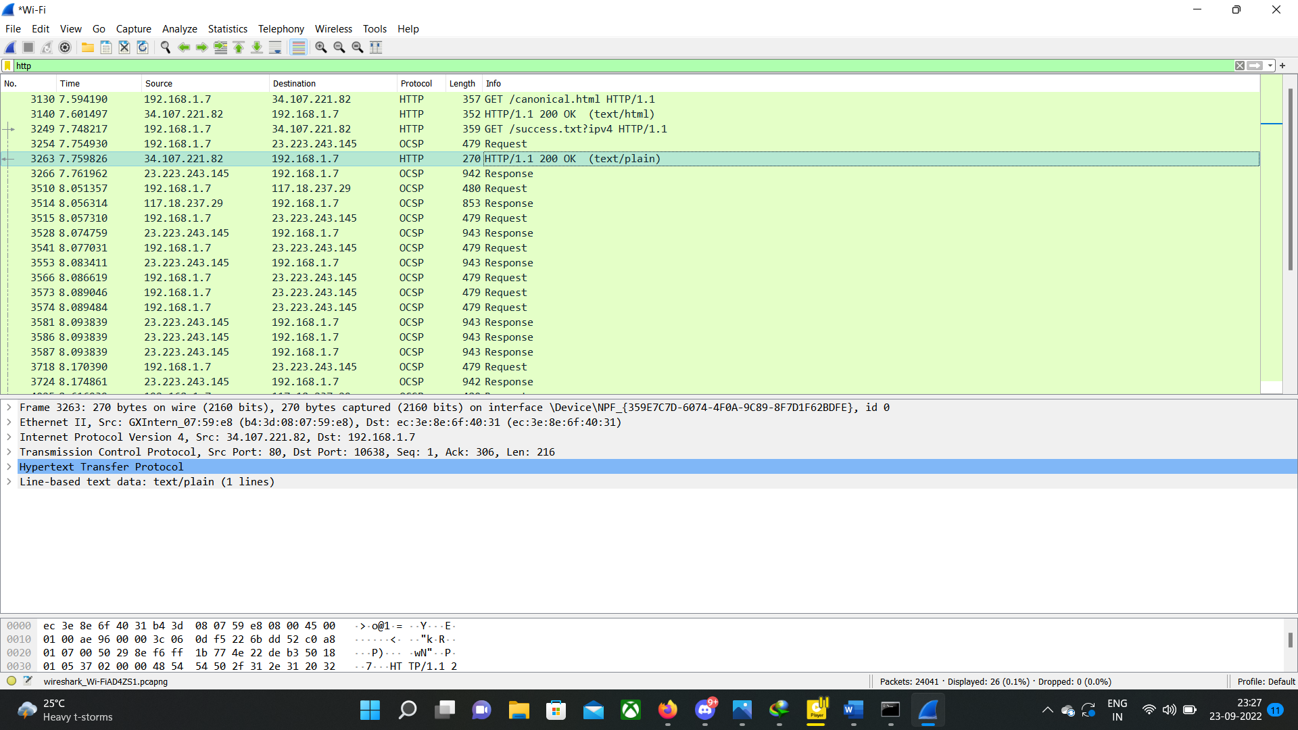

*From this tell if it is HTTP persistent or non-persistent?*

Non-persistent

Q6.

1. netstat -ano -p tcp
2. LISTEN